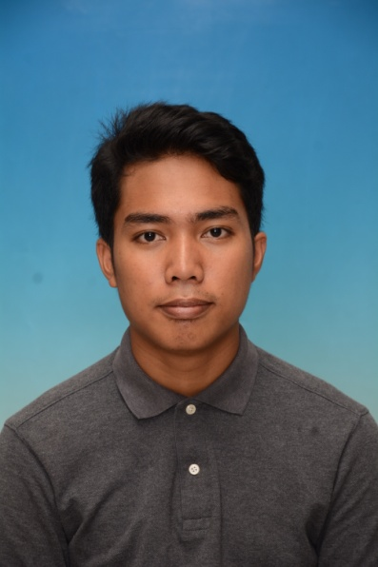

NAME: MOHD SUFFIAN BIN JAAFAR

HOMETOWN ADDRESS/CURRENT ADDRESS:
NO.4, JALAN BUDIMAN 2, TAMAN BUDIMAN, 86400,
PARIT RAJA, BATU PAHAT,
JOHOR

H/PHONE NO: 019-7963601

EMAIL: bintangpop93@gmail.com

PERSONAL PARTICULAR

Age : 24 Years Old
IC No : 930802-01-7105
Date of Birth : 2ndAugust 1993
Nationality: Malaysian

Race : Malay
Gender : Male
Marital Status : Single
Health : Excellent
EDUCATIONAL BACKGROUND

Highest Educational
Level : Certificate of Computer System and Support
Field of Study : Computer System and Support (SKS)
Institute / University : Kolej Komuniti Tanjung Piai
CGPA : 3.36

SecondHighest Education
Level : Pre-University (STPM 2012)
Major : Humanity
Institute : Sekolah Menengah Kebangsaan Tun Ismail.
PNGK : 2.00
M.U.E.T : Band 2

High School
Level : Sijil Pelajaran Malaysia (SPM 2010)
School : Sekolah Menengah Kebangsaan Tun Ismail.
Result : 1A-, 1B+, 2B, 1C+, 3C, 1D

Level : Penilaian Menengah Rendah (PMR 2008)
School : Sekolah Menengah Kebangsaan Tun Ismail.
Result :3B, 3C, 2D

CO-CURRICULARS ACTIVITIES

National level
Participant of Program Pasca Banjir Sekolah Angkat (2015)
Participant of the Most Number of Stompers in a Performance for Malaysian Book of Records (2014)
Participant of Kem Pemimpin Muda (KEMIDA) Jawatankuasa Perwakilan Pelajar (JPP) Peringkat Kebangsaan (2014)
Participant ofProgram Latihan Khidmat Negara (2013)

University/College level
Participant of I Love English Carnival for Johor Community College (2015)

Pre-University (Form 6) level
Participant of Pertandingan Badminton Pra-Universiti SMK Tun Ismail (2012)
Participant of Program Selangkah Menuju Generasi Hebat (2012)
Participant of Pertandingan Bowling Pra-Universiti SMK Tun Ismail (2011)

Secondary School level
Participant of a Fun Day with English Programme SMK Tun Ismail (2010)
Participant of a Fun Morning with English Programme SMK Tun Ismail (2010)
Participant of Scrabble Competition SMK Tun Ismail (2008)

SKILLS AND ABILITY

Experiences

- Industrial training attachment for 3½month at Majlis Perbandaran Batu Pahat (MPBP). (Please refer to the letter from the company)

Computer (Based from working experiences)

- Good knowledge in basic computer programs. (Microsoft Office and Internet.)
- Skilled in computer setup and maintenance.
- Skilled in network wiring and connection.
- Can perform installation, configuration and support of Microsoft Windows Operating systems and related services.
- Can perform installation, configuration and troubleshooting of printer.
- Can perform data entry task through Microsoft Excel.
- Skilled in computer connection to projector.
- Skilled in customizing company’swebsite.

Language

- Able to write and speak inBahasa Malaysia
- Able to write and speak in English

REFERENCES
- Haji Ahmad bin Othong, Secretary of Co-Curriculum (Form 6), SMK Tun Ismail.
- Miss Goh Eg Su, Head of Industrial Training Department, Kolej Komuniti Tanjung Piai. (07-6869600)

